Deploy Netflix Clone on Kubernetes

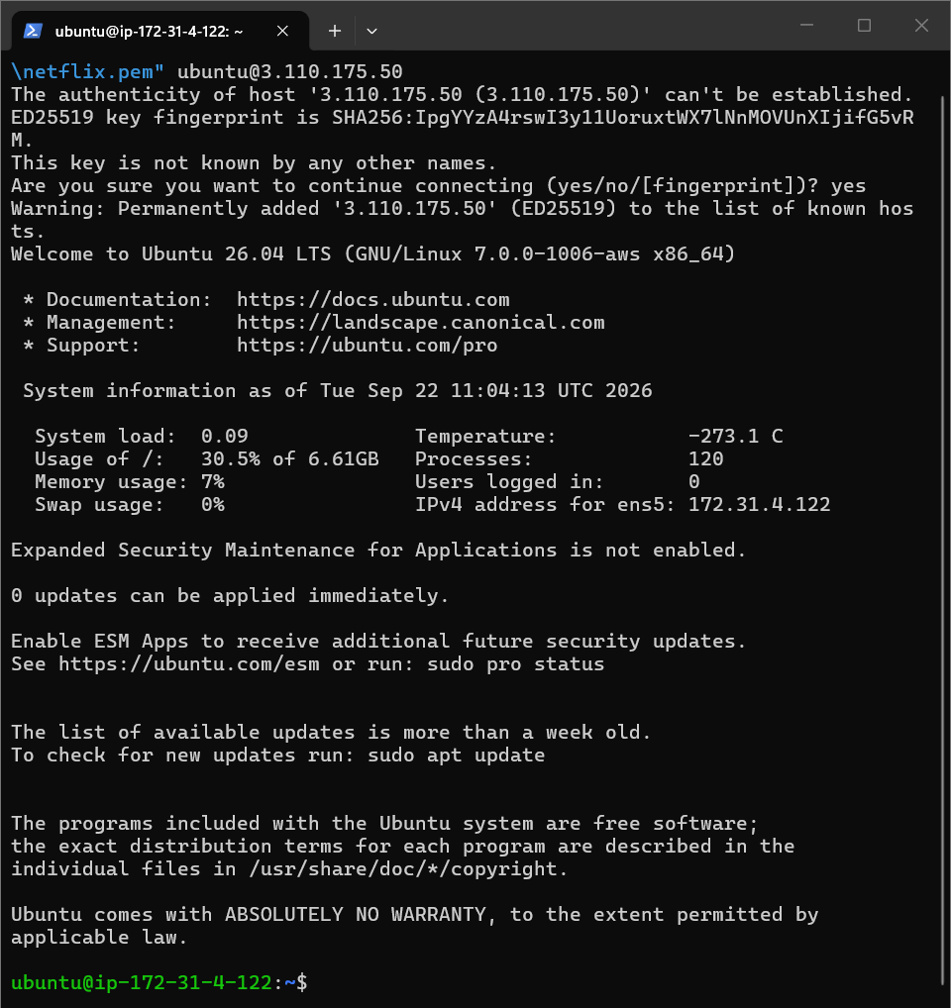

sudo apt update
sudo apt upgrade -y

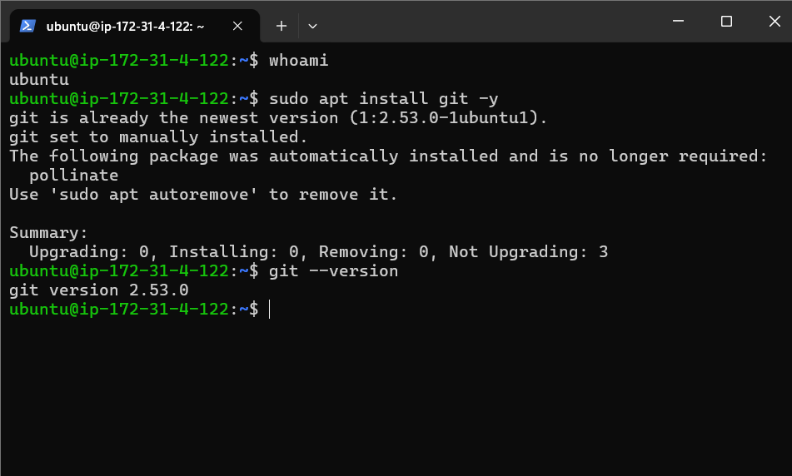

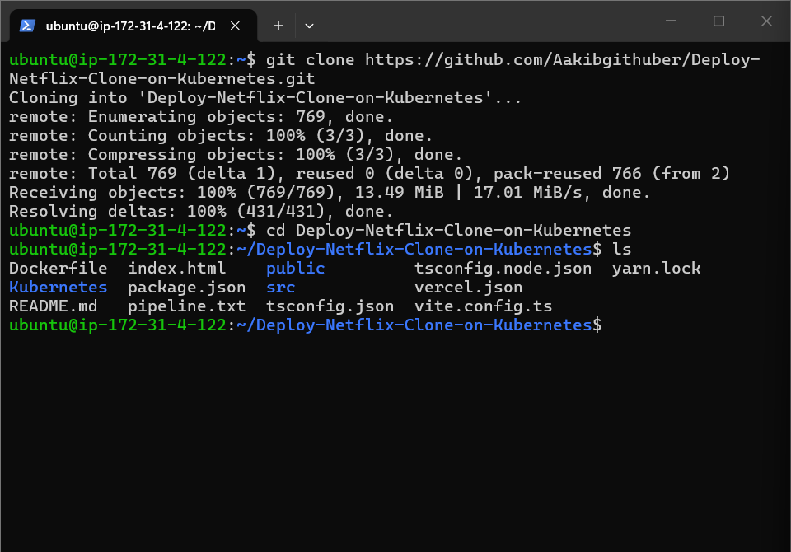

App run on ec2

sudo apt install docker.io -y

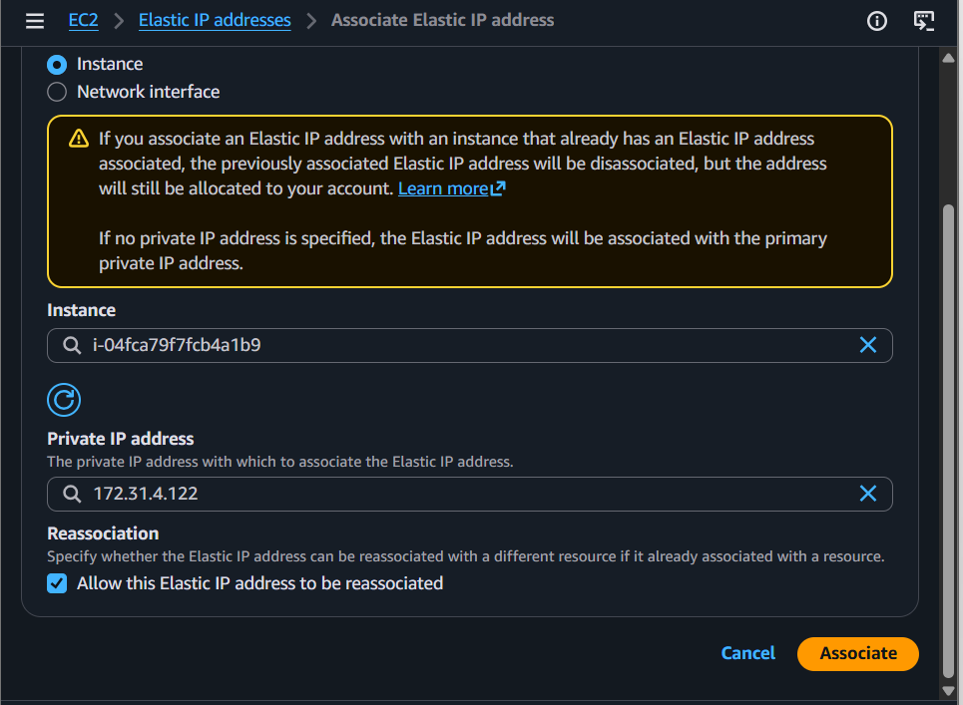

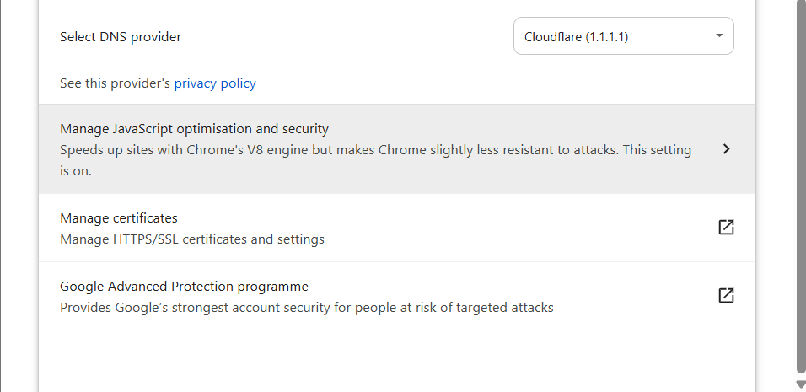



https://www.themoviedb.org/settings/api

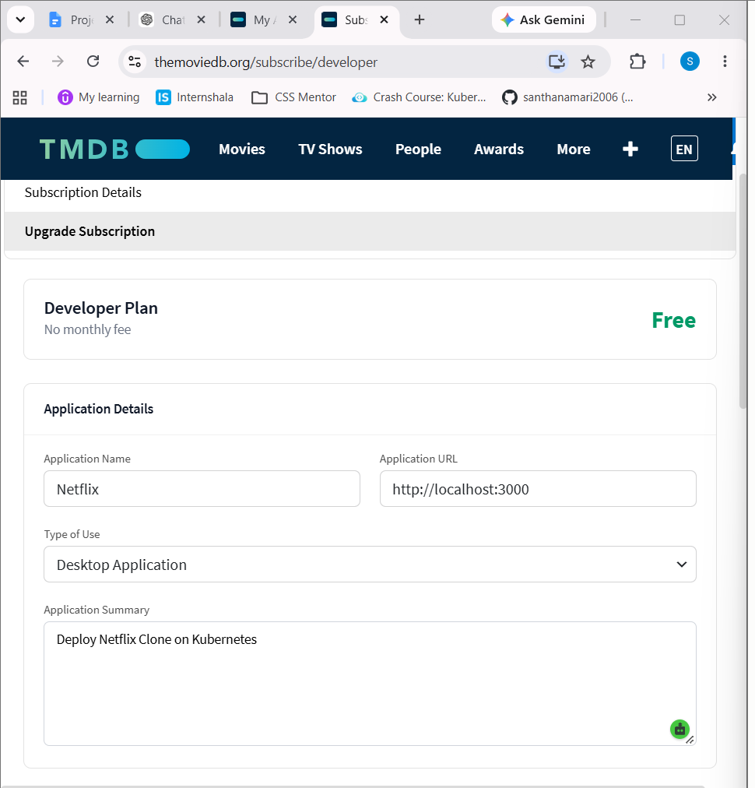

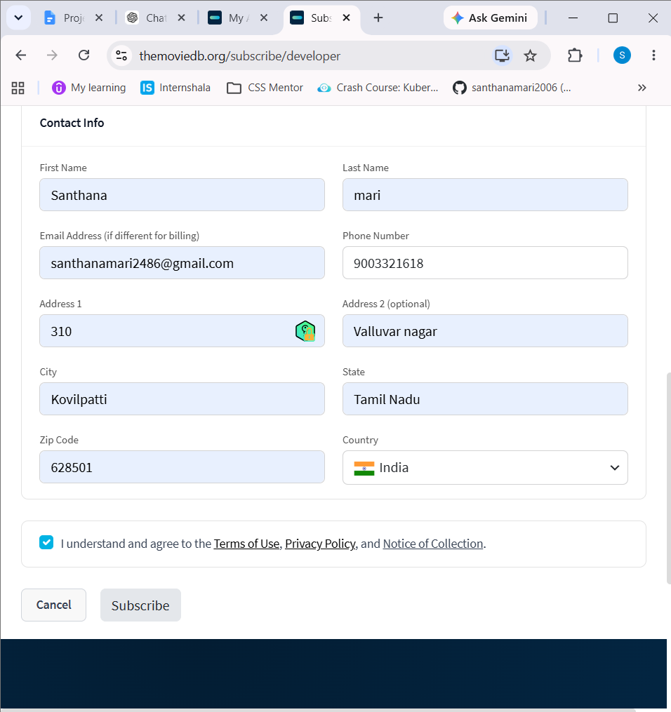

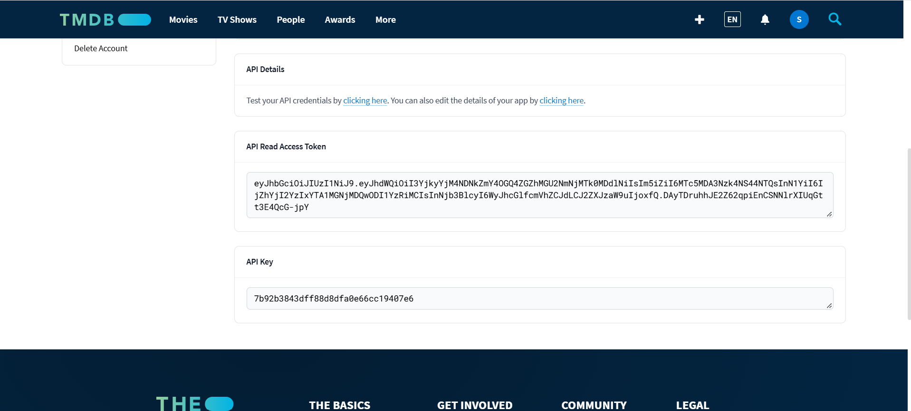

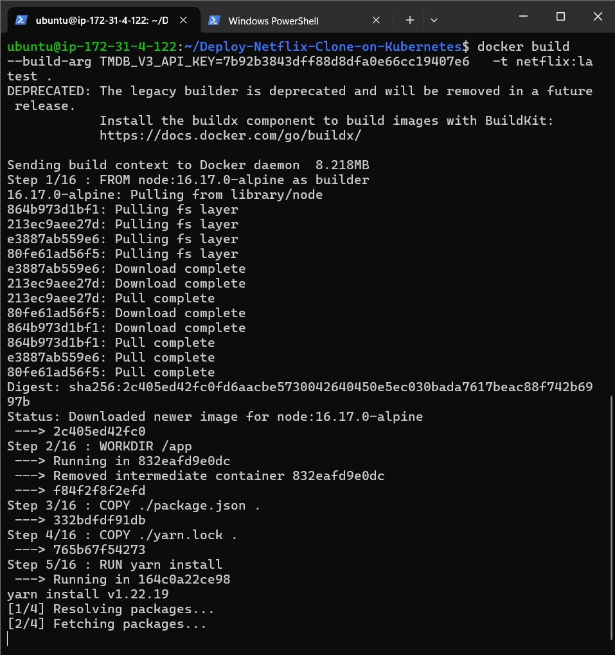

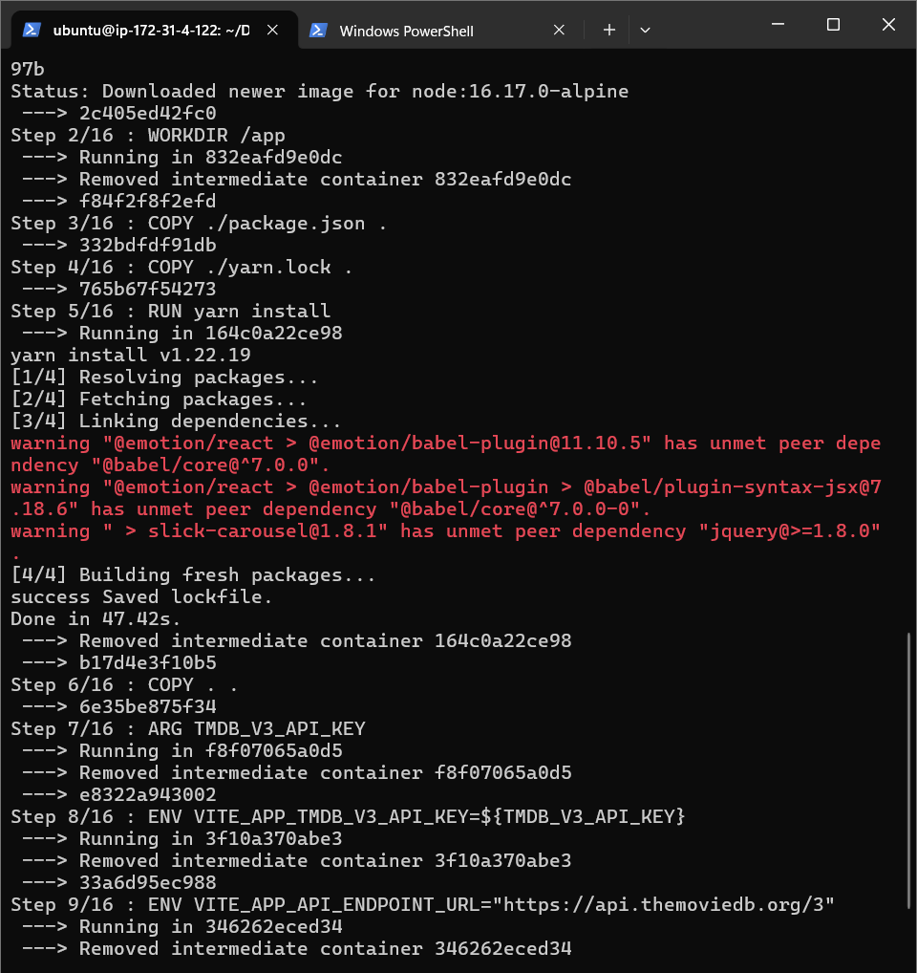

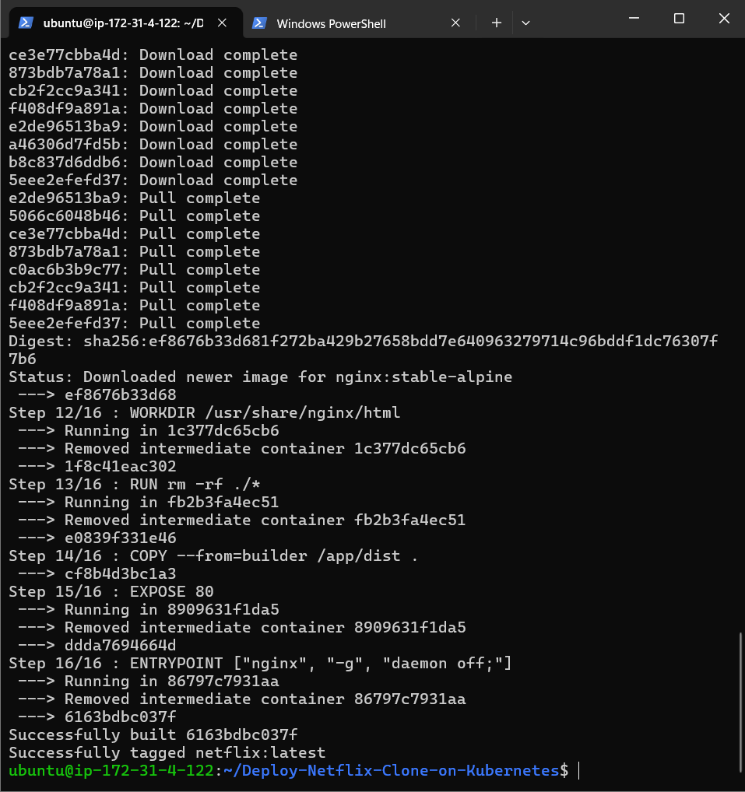

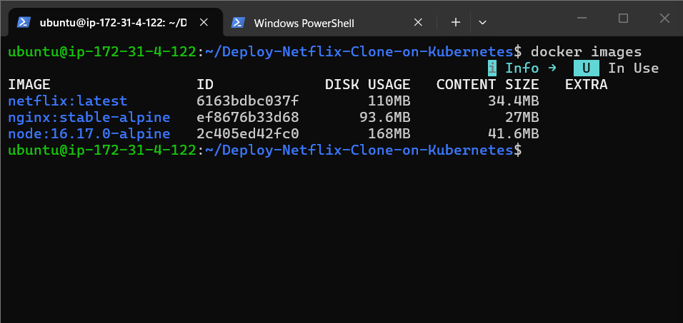

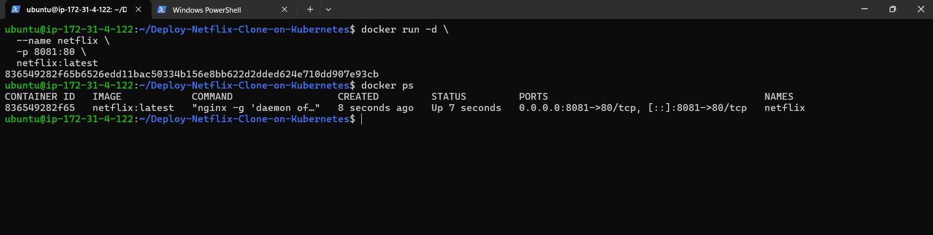

http://15.252.189.54:8081/browse



Netflix-clone application is successfully running on your AWS EC2 server.

Now run sonarqube

docker run -d \
--name sonarqube \
-p 9000:9000 \
sonarqube:lts-community

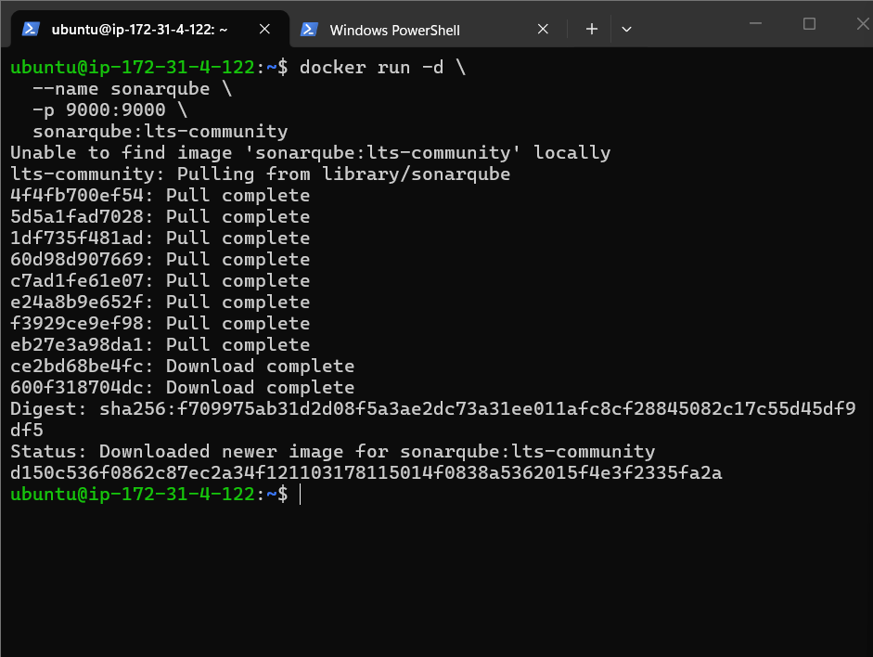

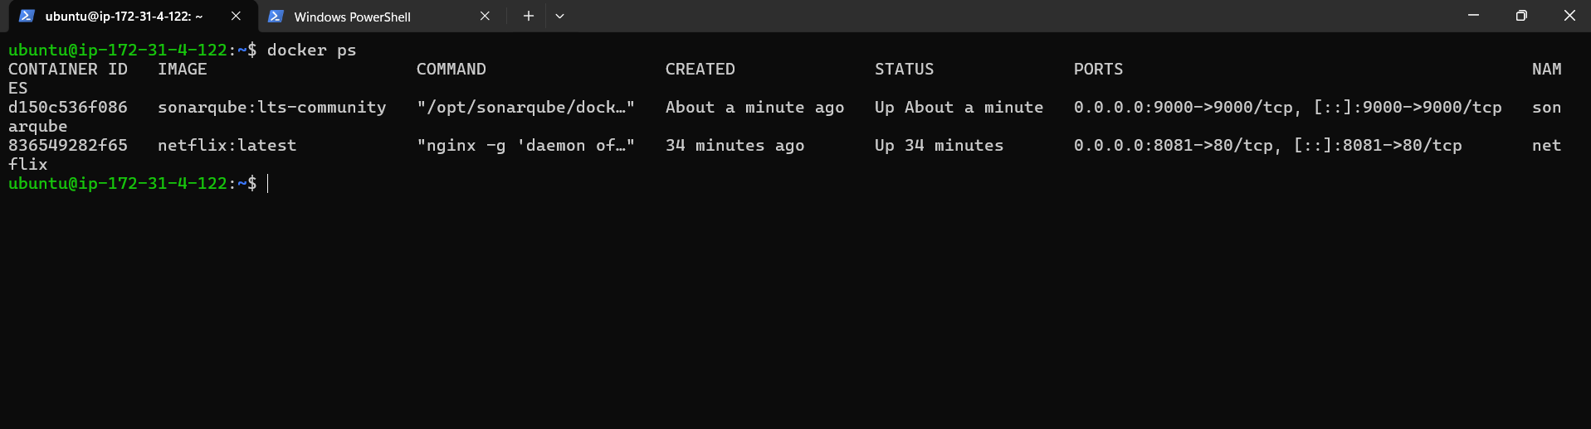

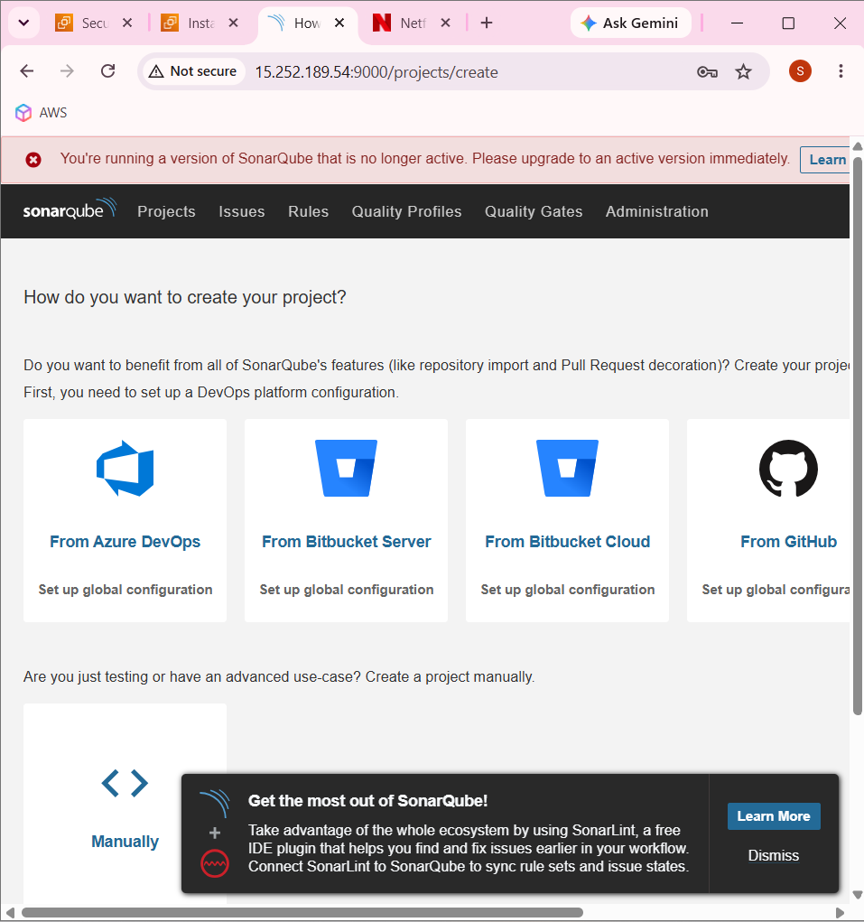

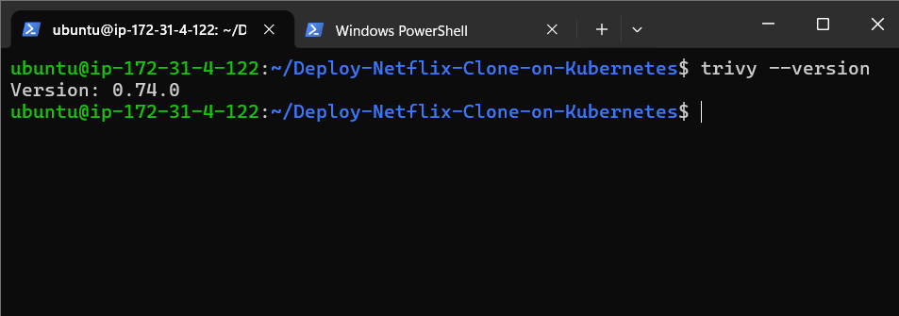

sudo apt install -y trivy

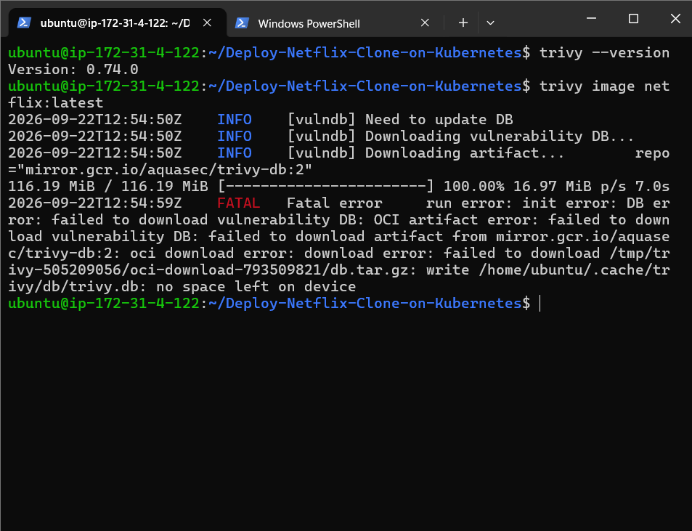

trivy image netflix:latest => to security-scan your Docker image before deploying it.

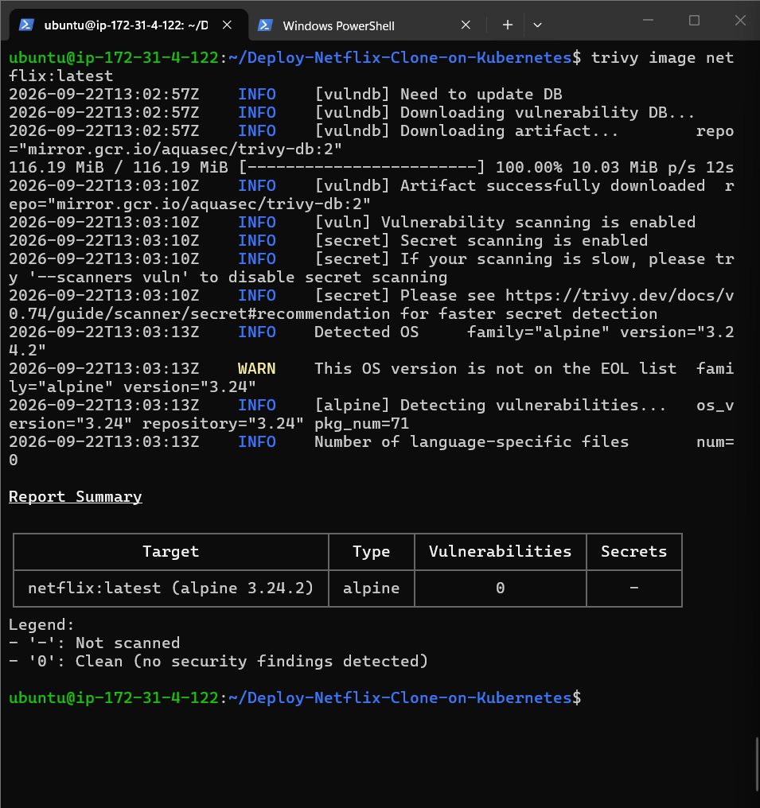

71 packages scanned 0 vulnerabilities

Java

sudo apt update

sudo apt install -y fontconfig openjdk-21-jre

Java –version

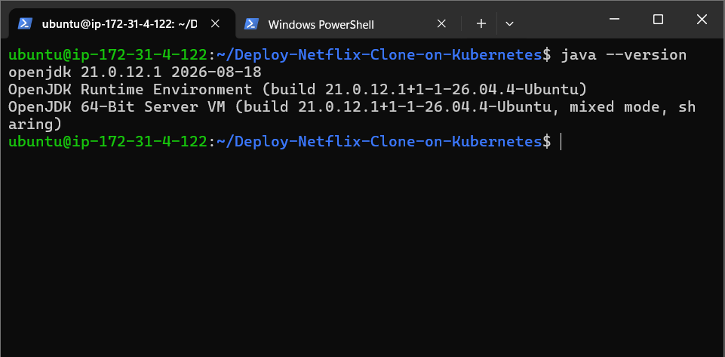

Java installed

Jenkins

sudo wget -O /etc/apt/keyrings/jenkins-keyring.asc \
https://pkg.jenkins.io/debian-stable/jenkins.io-2026.key

Jenkins signing key

echo "deb [signed-by=/etc/apt/keyrings/jenkins-keyring.asc] https://pkg.jenkins.io/debian-stable binary/" | \
sudo tee /etc/apt/sources.list.d/jenkins.list > /dev/null

Jenkins LTS Repository

sudo apt update

sudo apt install -y jenkins

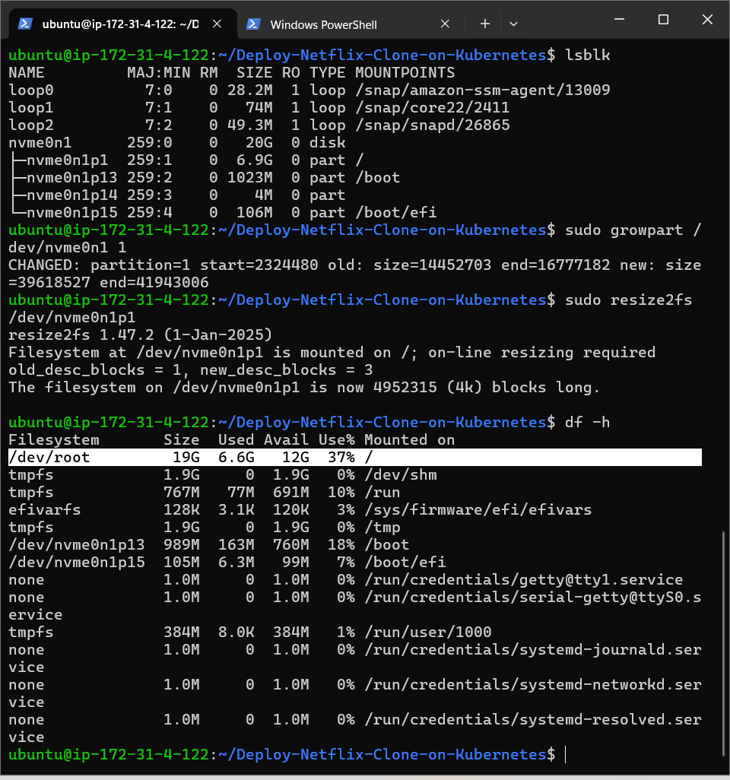

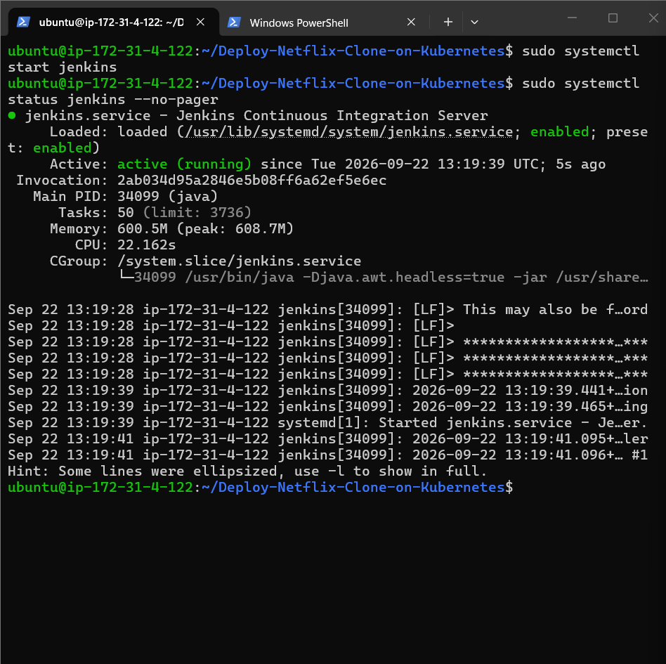

Jenkins is running

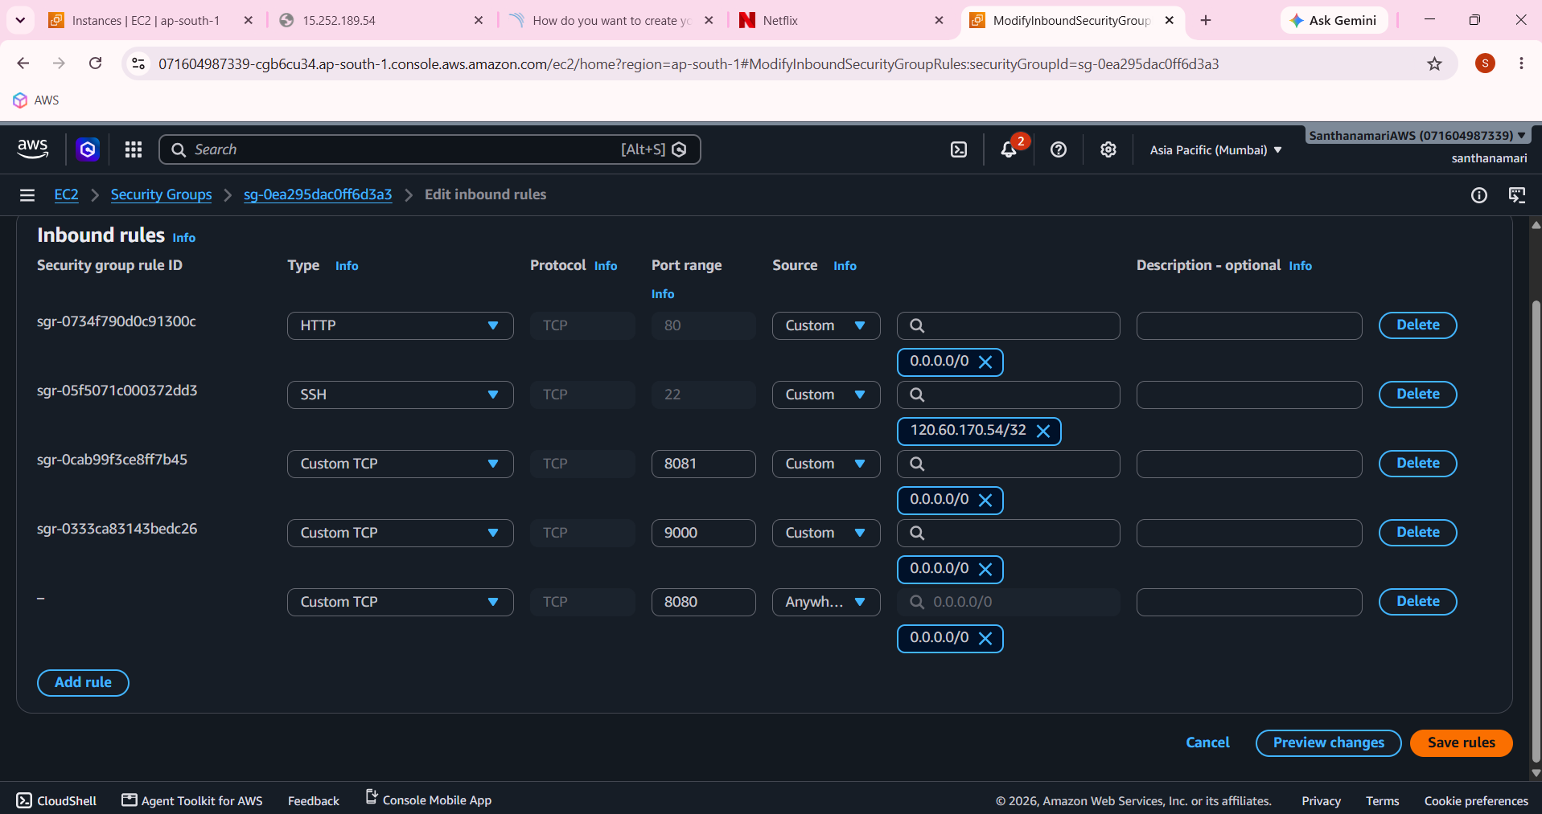

sudo cat /var/lib/jenkins/secrets/initialAdminPassword => jenkins adminpassword

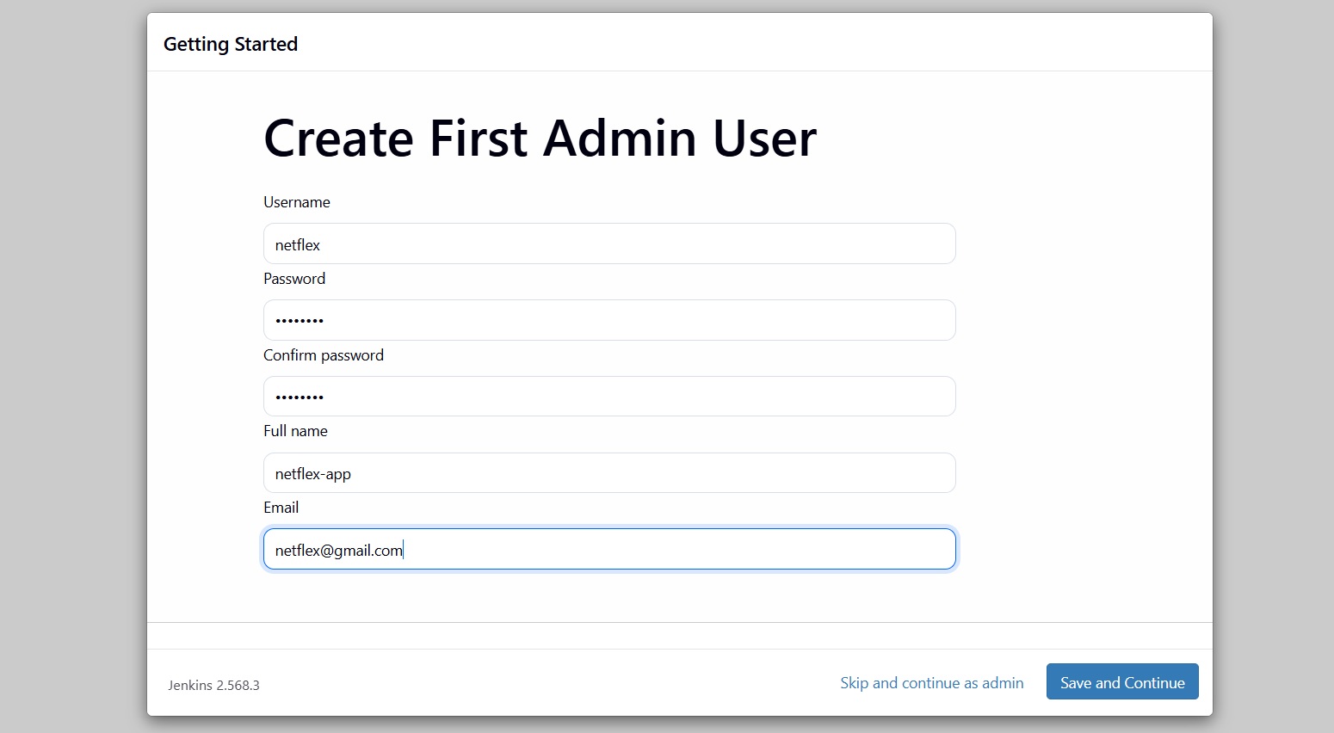

santhanamarig/netflex
docker push santhanamarig/netflex:tagname

docker login -u santhanamarig

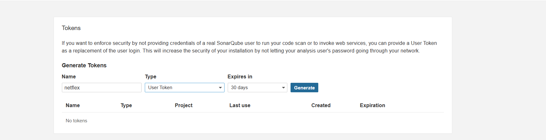

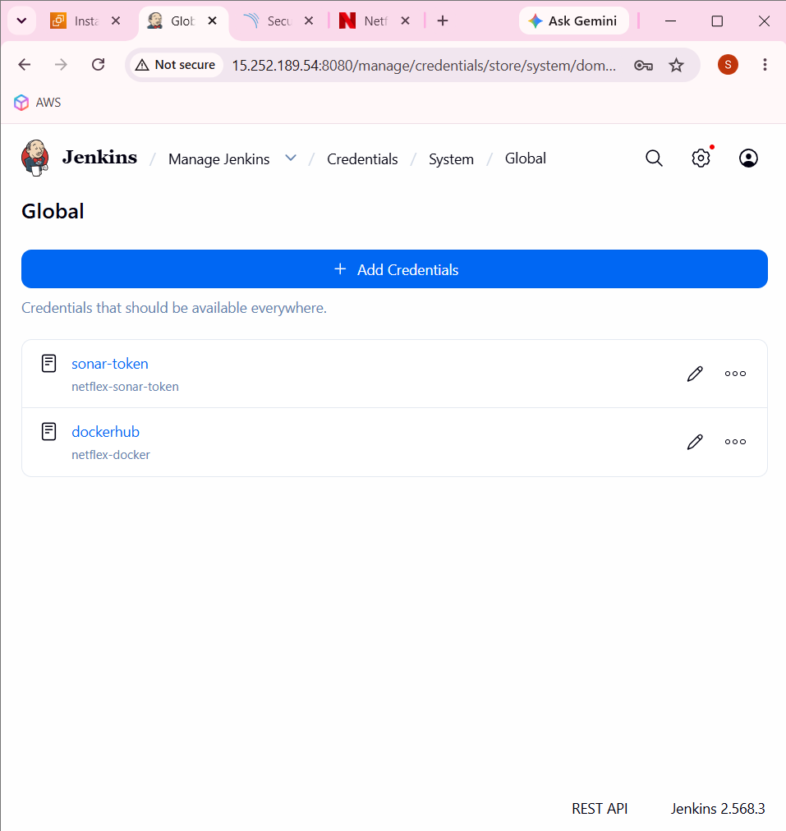

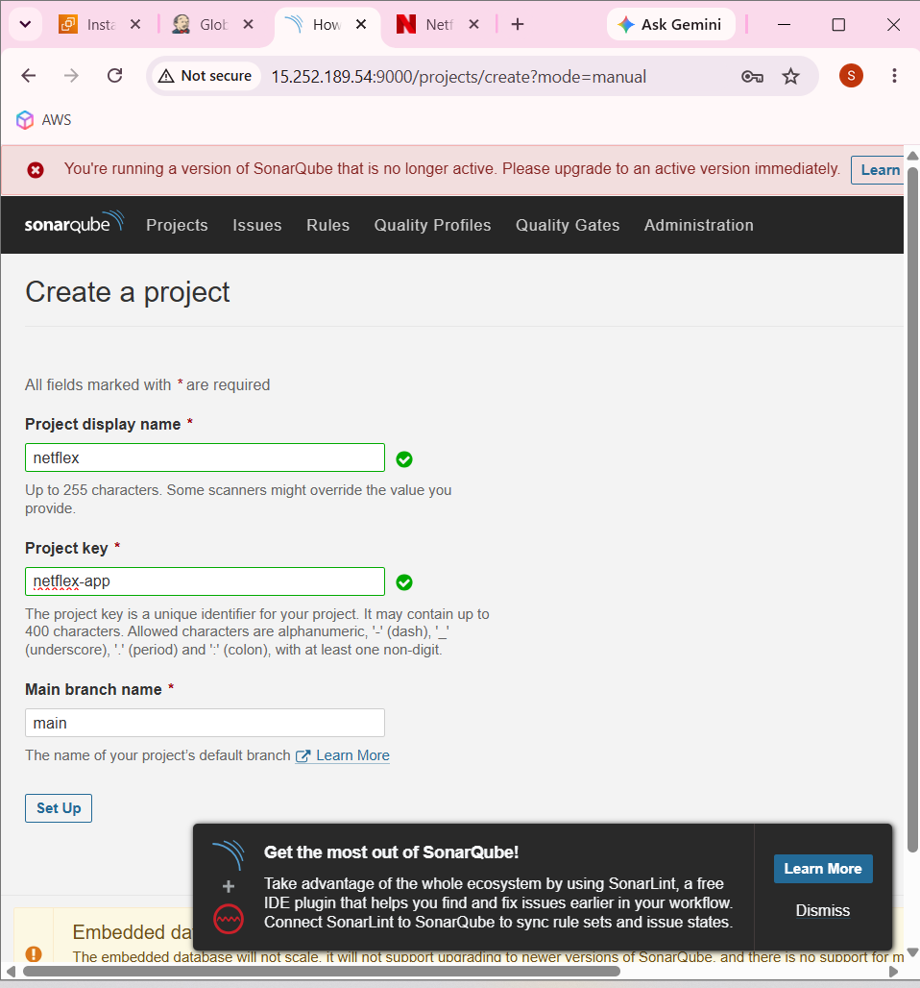

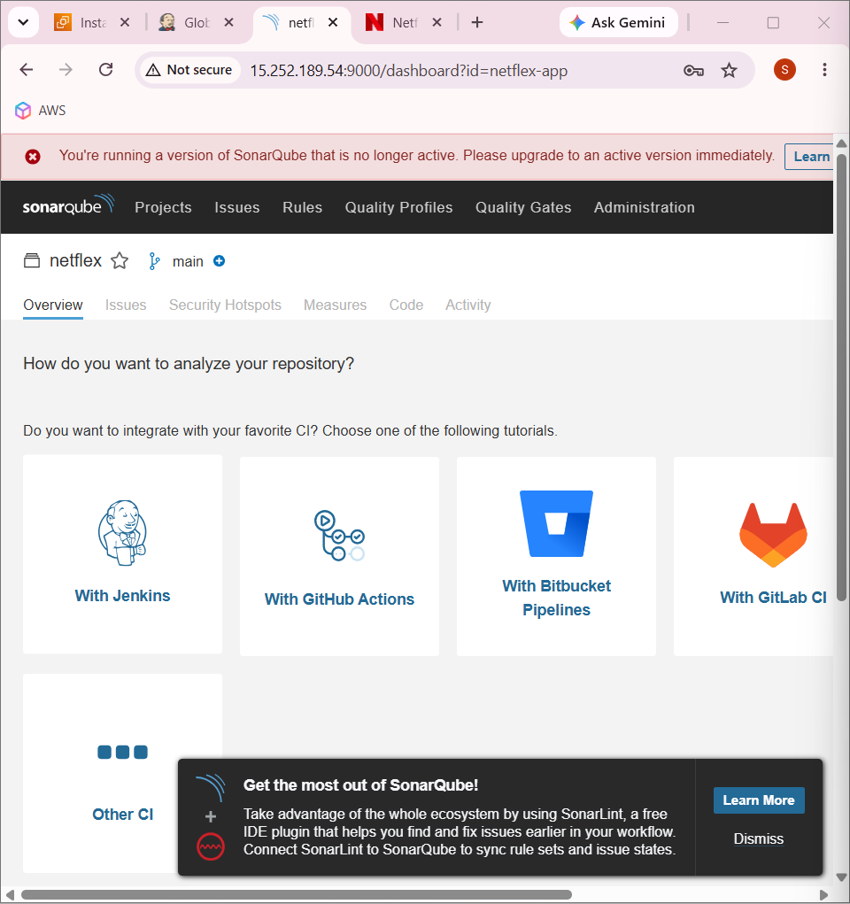

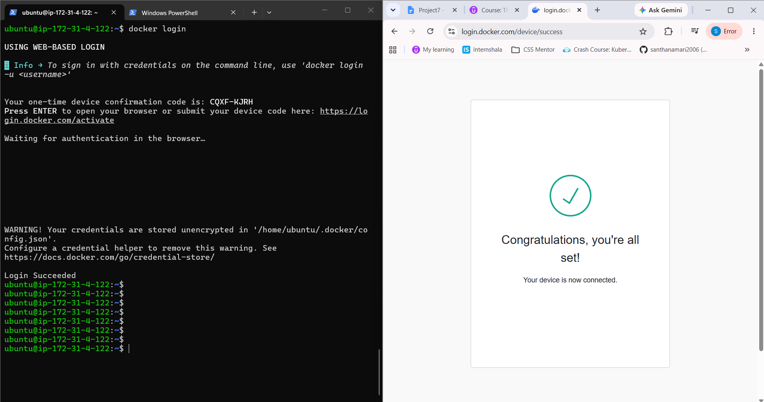

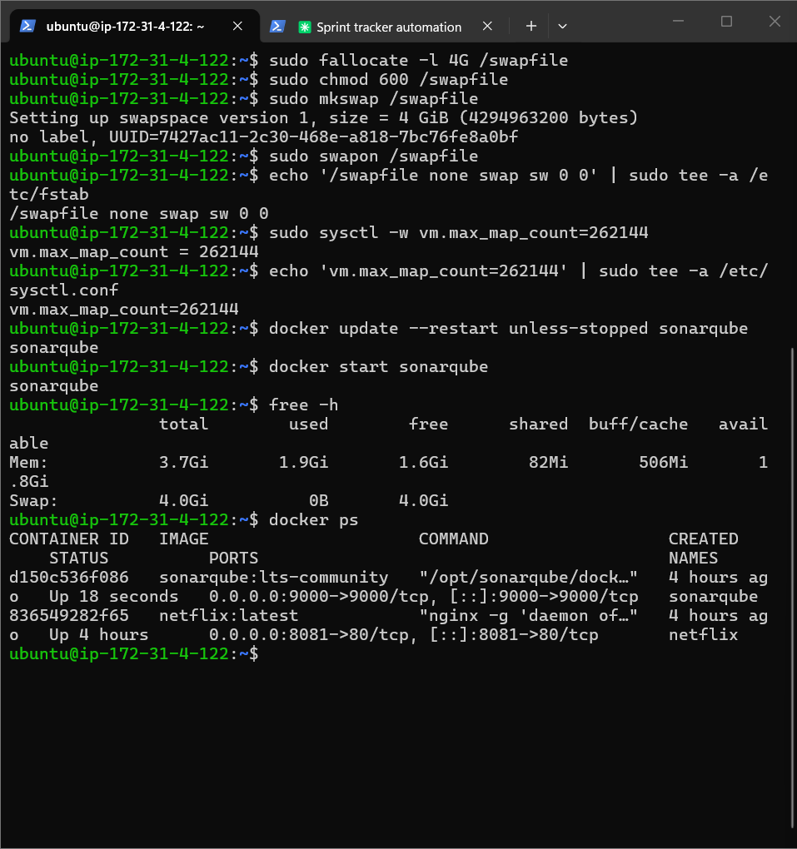

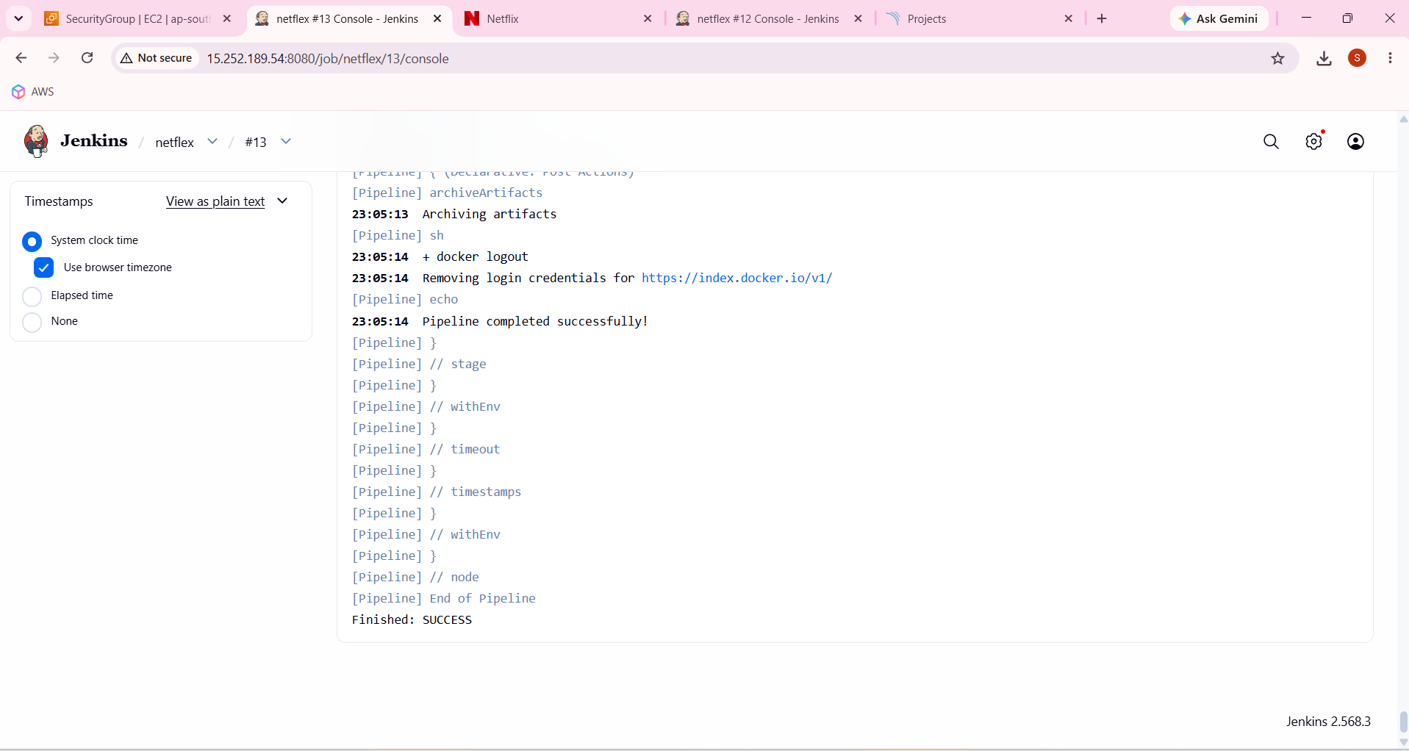

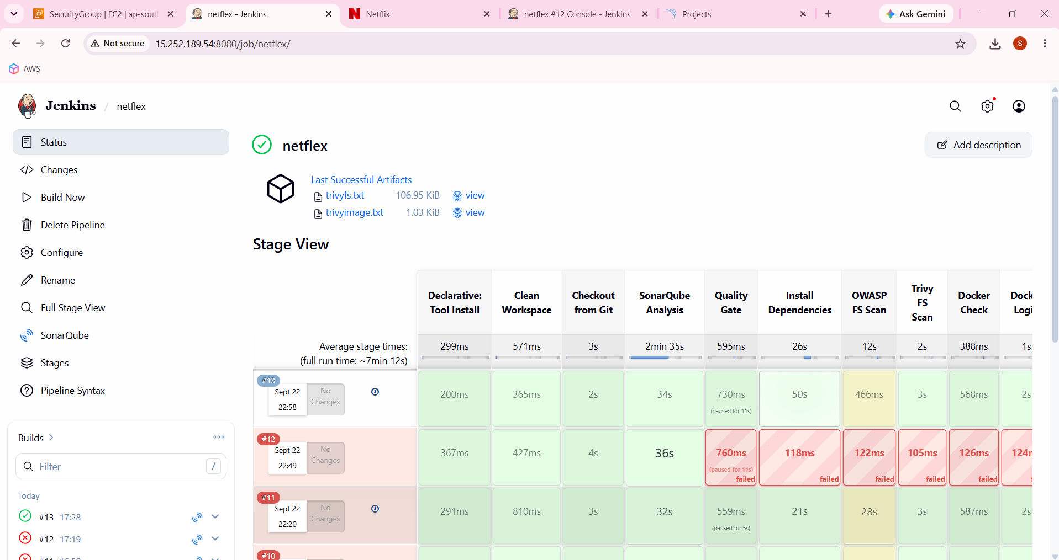

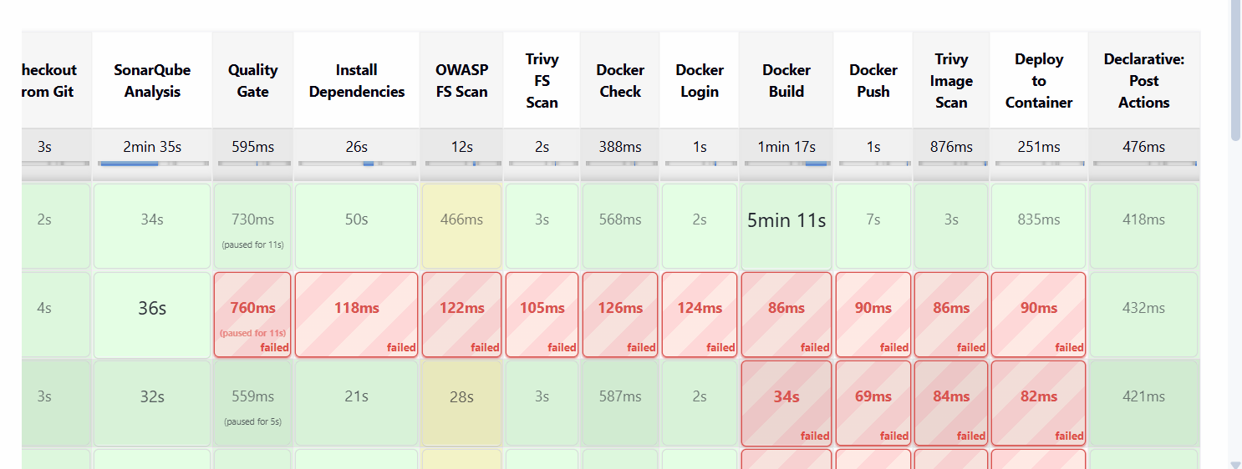

Sonarqube

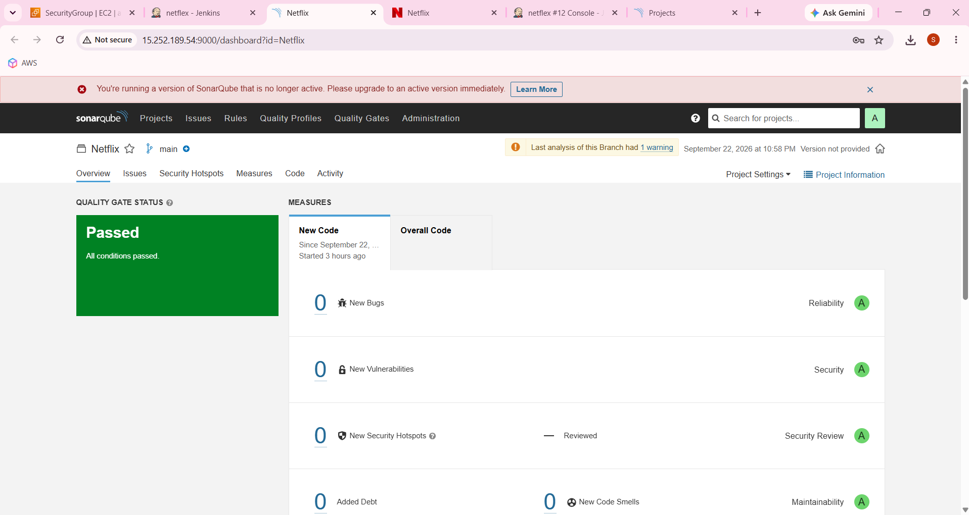

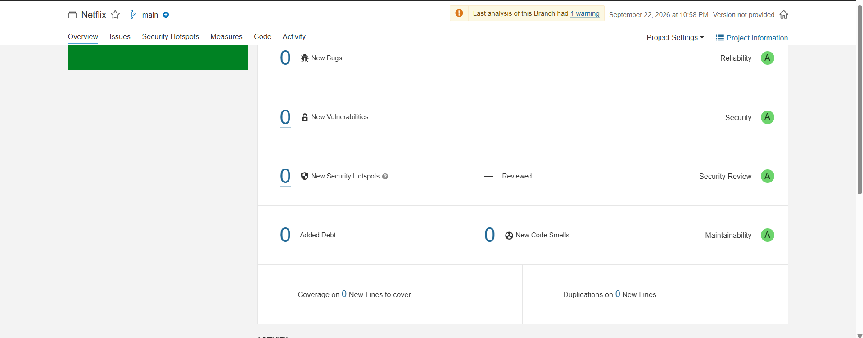
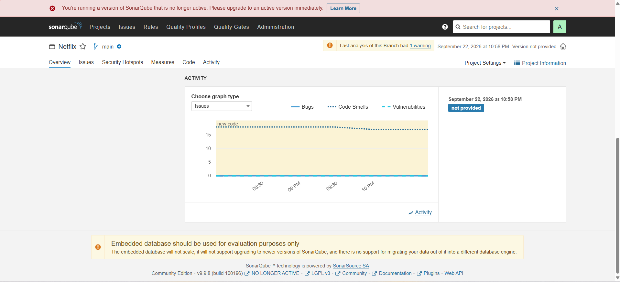

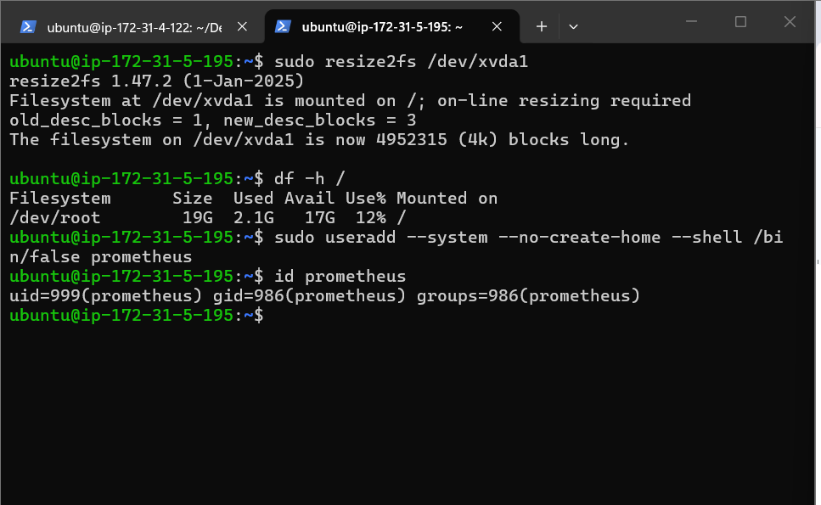

prometheus

sudo useradd --system --no-create-home --shell /bin/false prometheus
id prometheus

Download prometheus

wget https://github.com/prometheus/prometheus/releases/download/v2.47.1/prometheus-2.47.1.linux-amd64.tar.gz

ls -lh prometheus-2.47.1.linux-amd64.tar.gz

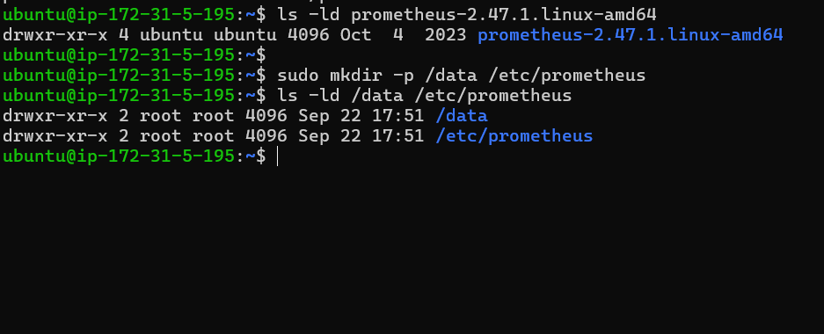

sudo mv prometheus-2.47.1.linux-amd64/prometheus prometheus-2.47.1.linux-amd64/promtool /usr/local/bin/

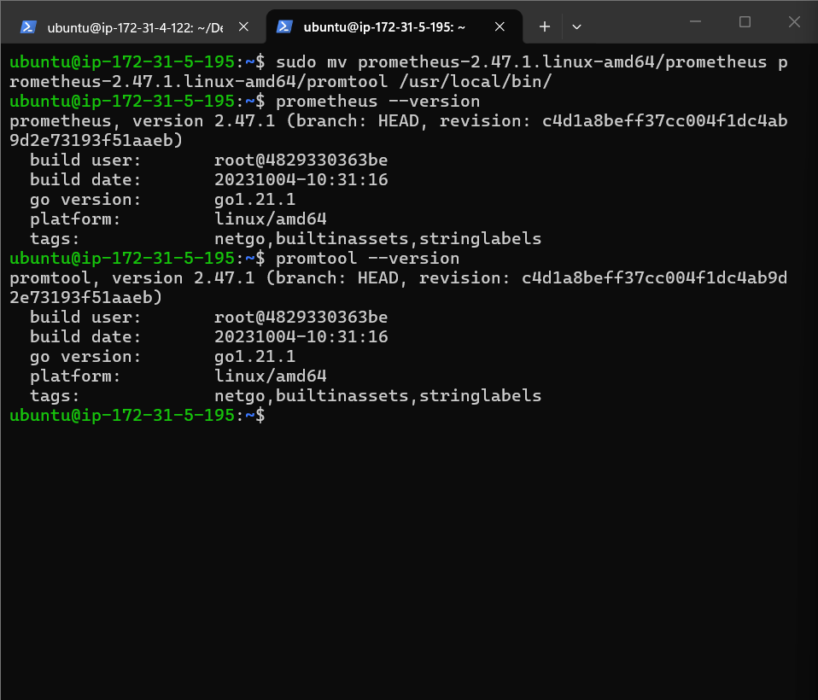

Move pro conf file

sudo mv prometheus-2.47.1.linux-amd64/consoles/ \
prometheus-2.47.1.linux-amd64/console_libraries/ \
/etc/prometheus/

sudo mv prometheus-2.47.1.linux-amd64/prometheus.yml \
/etc/prometheus/prometheus.yml

ls -l /etc/prometheus

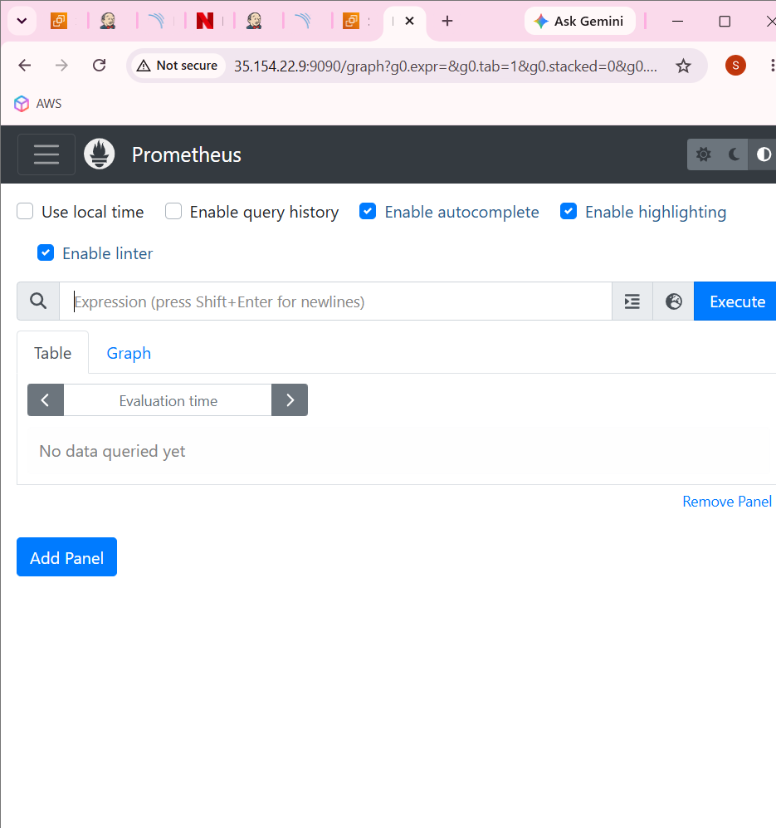
wget https://github.com/prometheus/node_exporter/releases/download/v1.6.1/node_exporter-1.6.1.linux-amd64.tar.gz
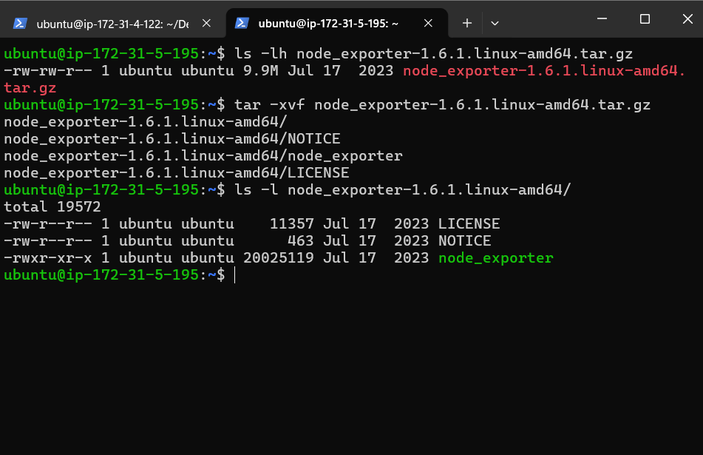

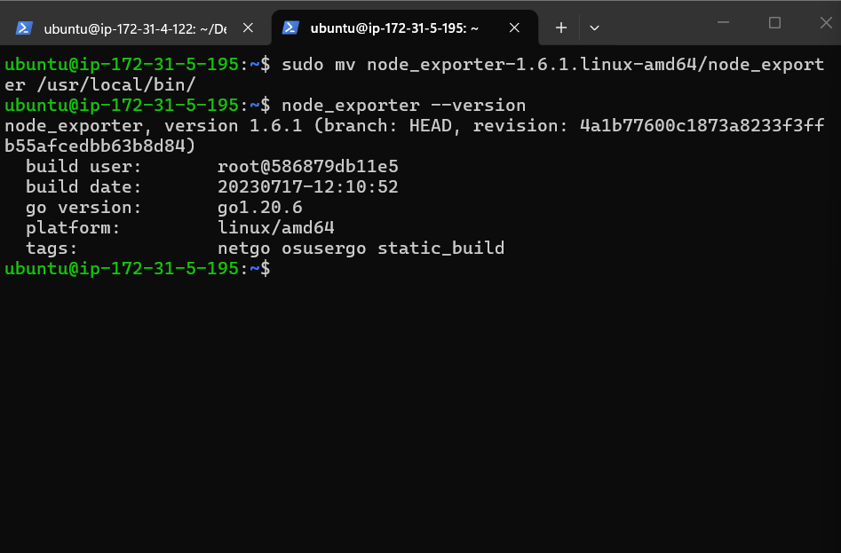
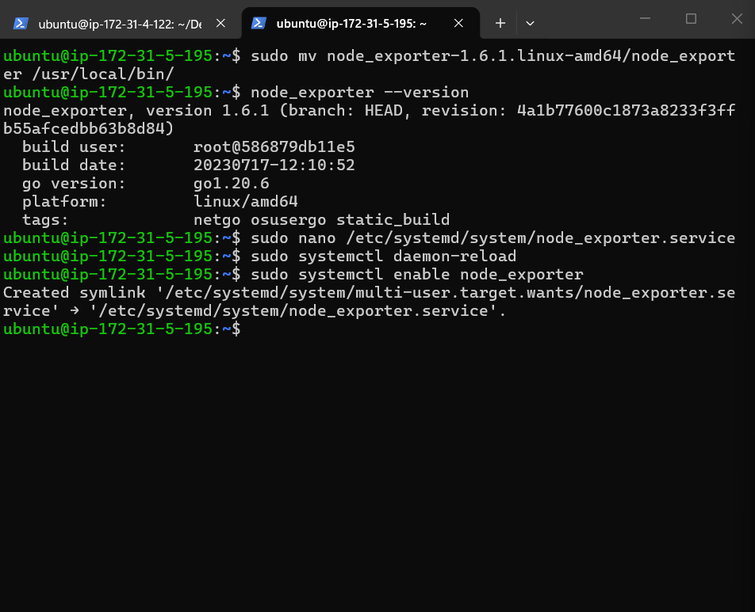

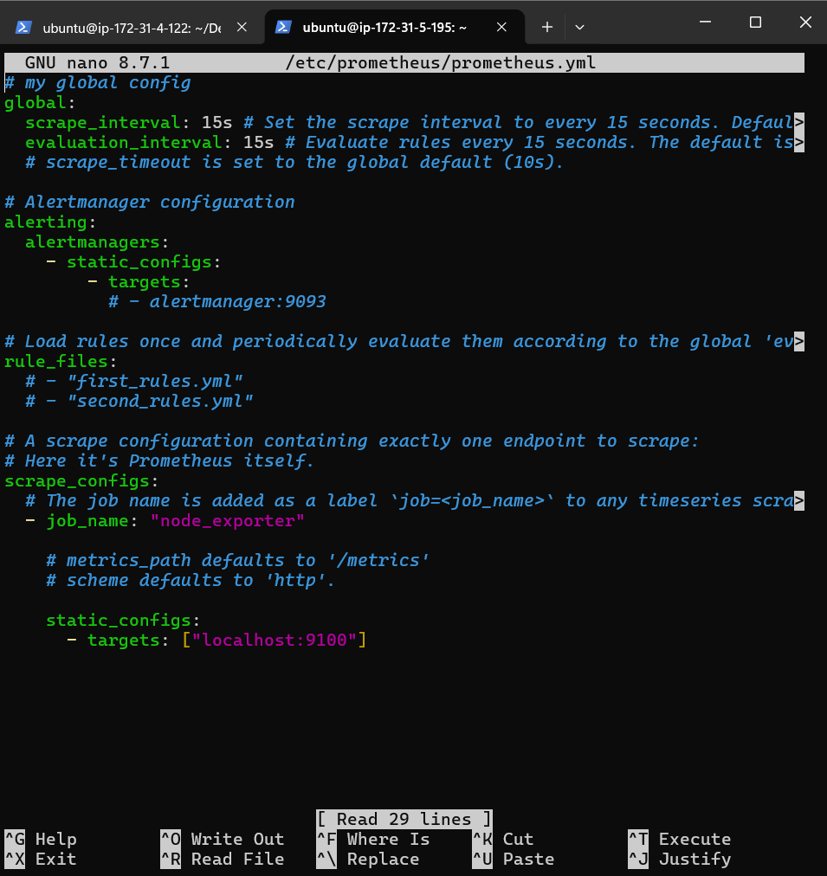

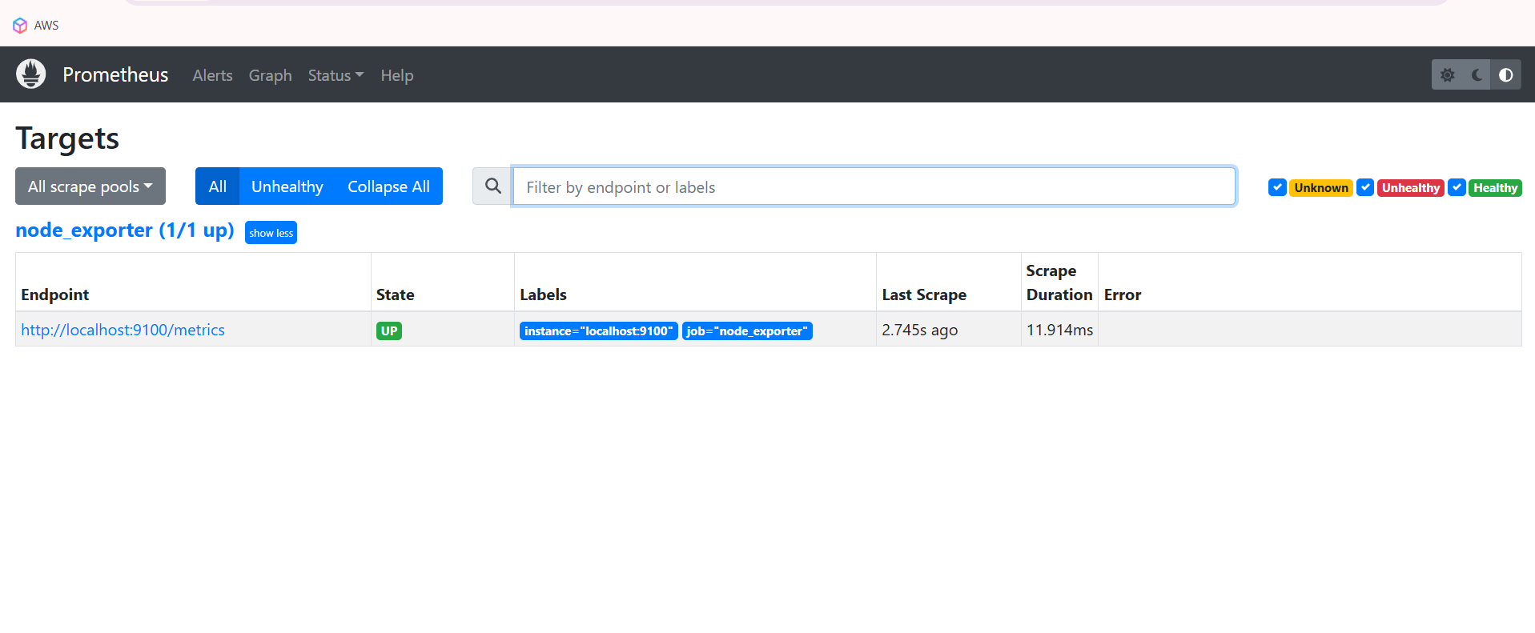

Prometheus successfully contacted Node Exporter and collected metric

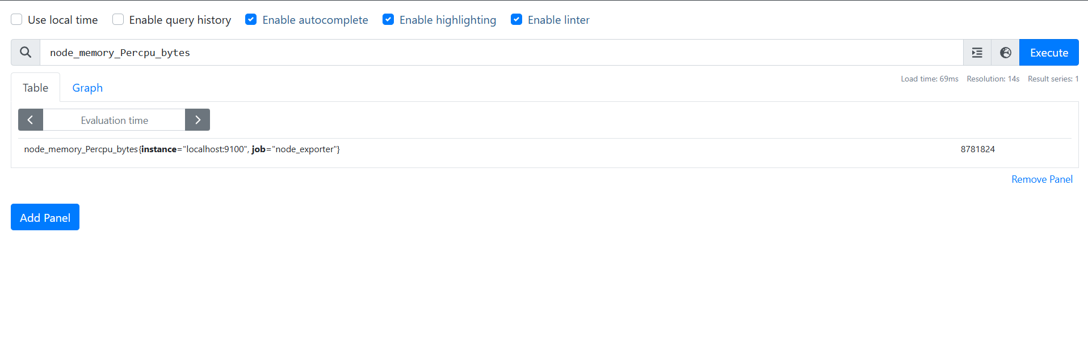

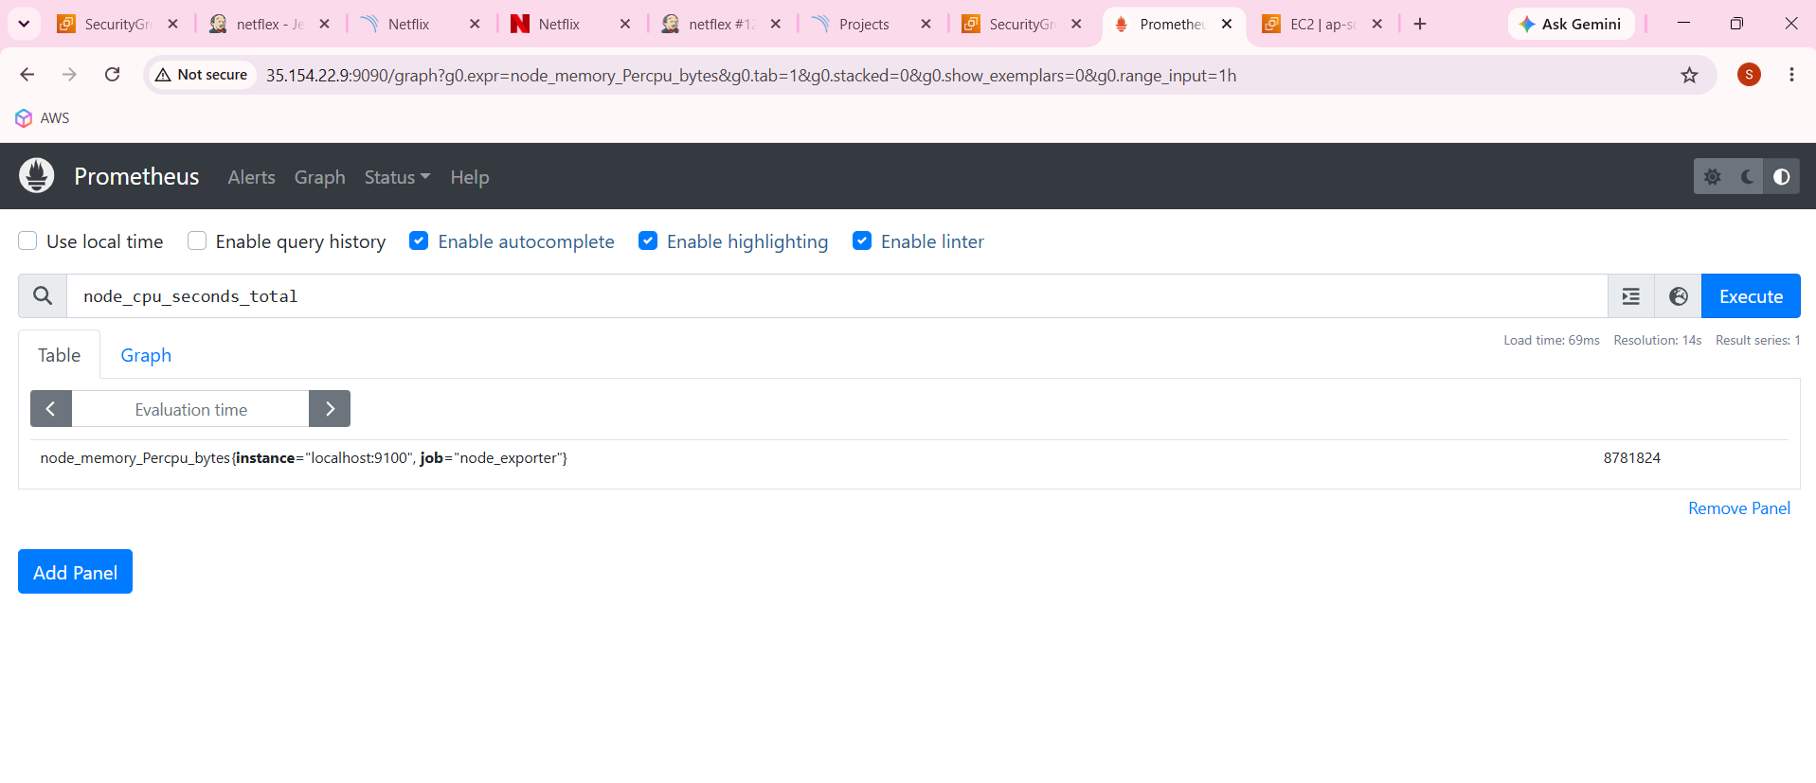

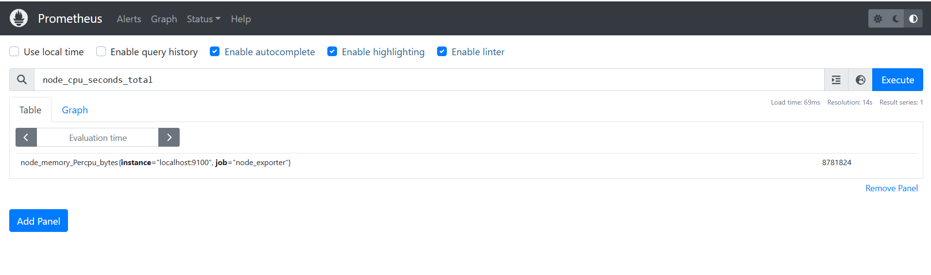

sudo apt-get install -y grafana

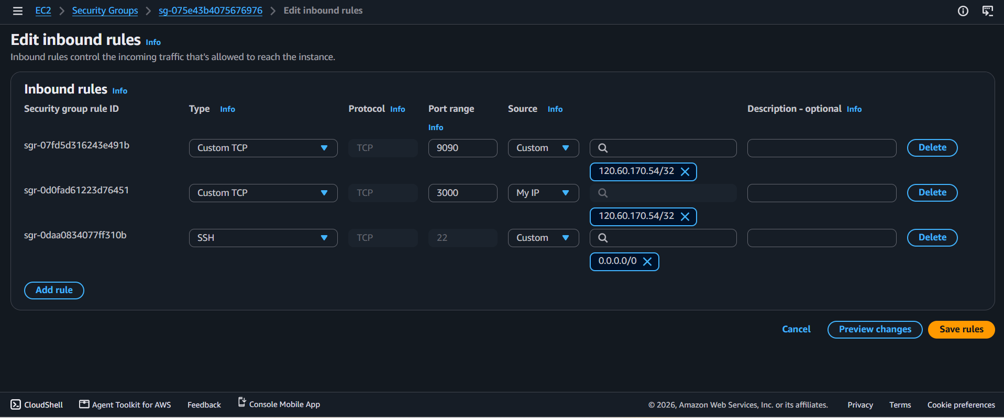

sudo mkdir -p /etc/apt/keyrings

wget -q -O - https://apt.grafana.com/gpg.key | gpg --dearmor | sudo tee /etc/apt/keyrings/grafana.gpg > /dev/null

echo "deb [signed-by=/etc/apt/keyrings/grafana.gpg] https://apt.grafana.com stable main" | sudo tee /etc/apt/sources.list.d/grafana.list

sudo apt-get update

sudo apt-get install -y grafana

sudo systemctl daemon-reload

sudo systemctl enable grafana-server

sudo ss -lntp | grep 3000

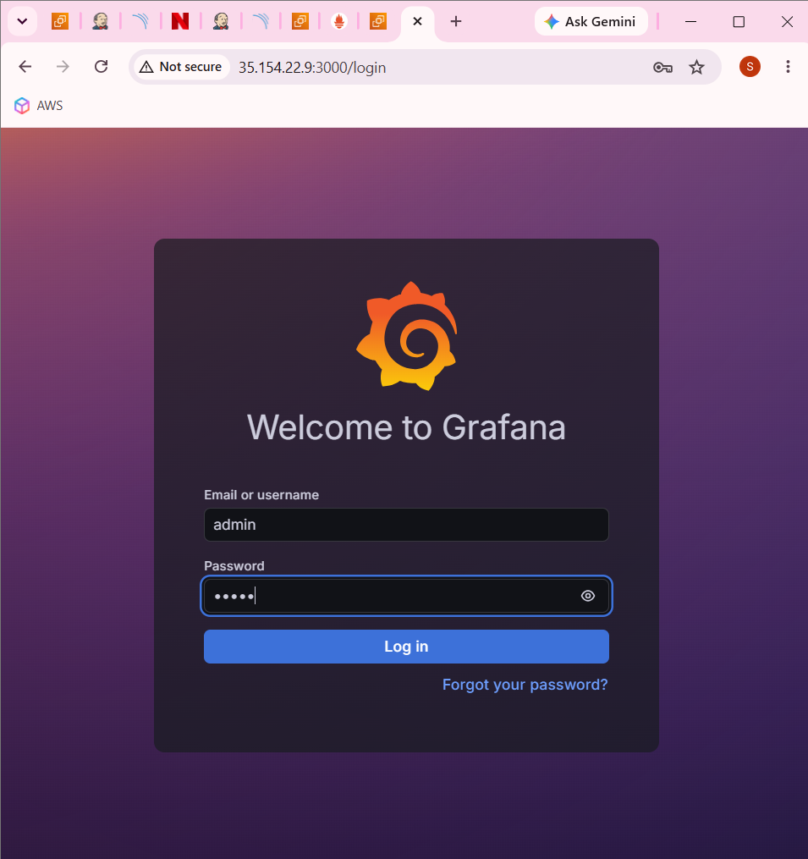

Admin admin

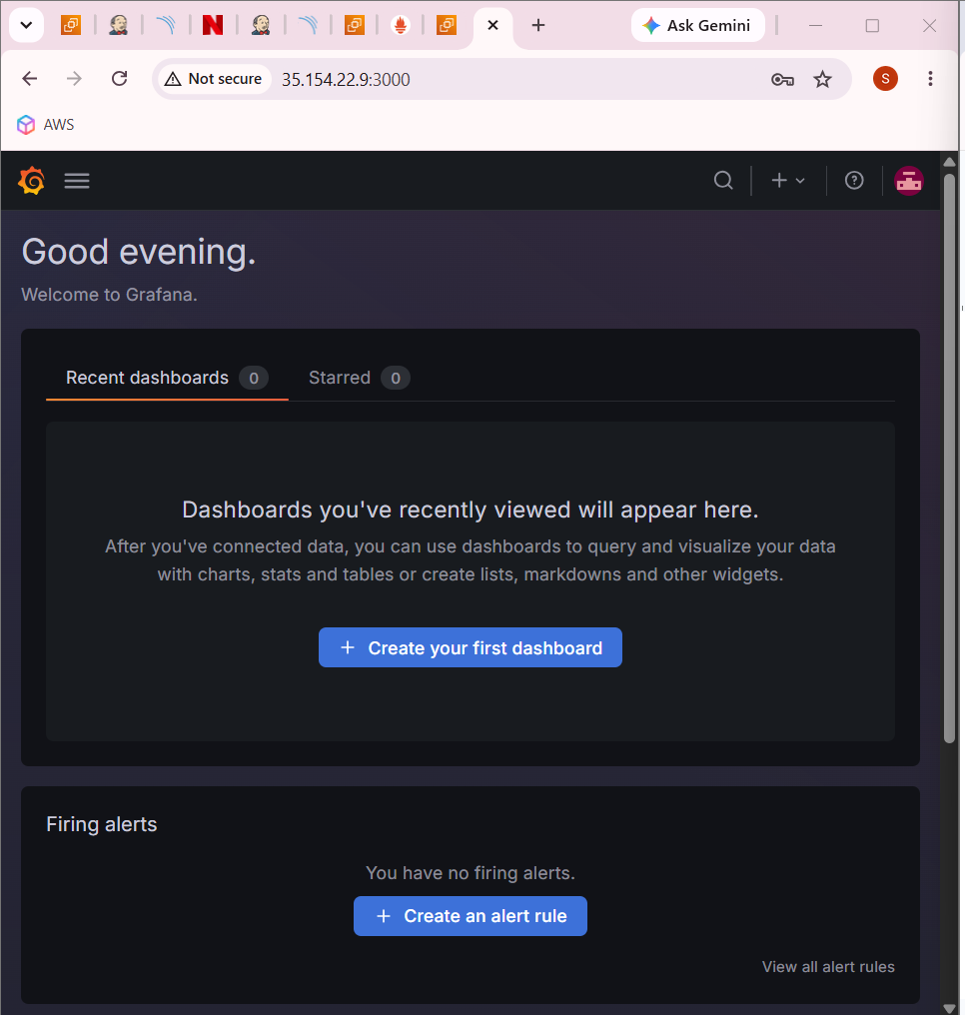

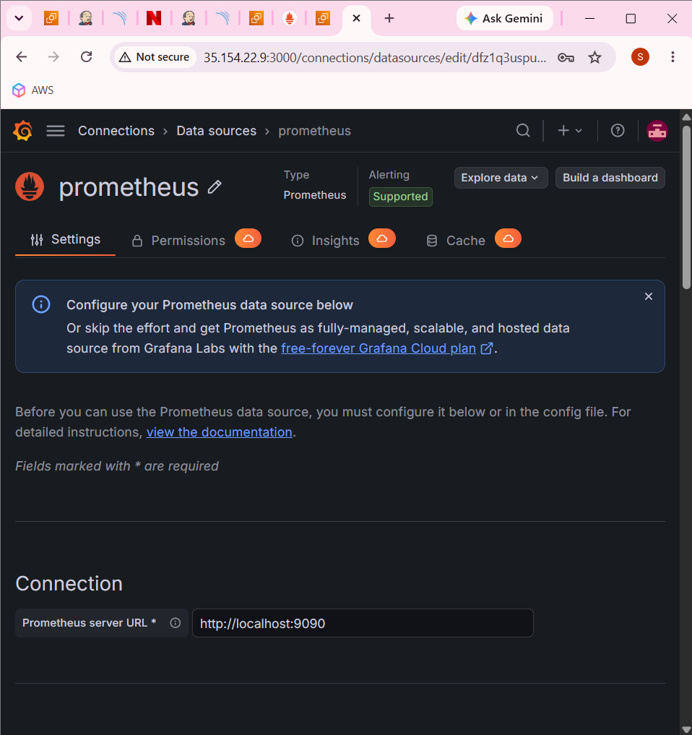

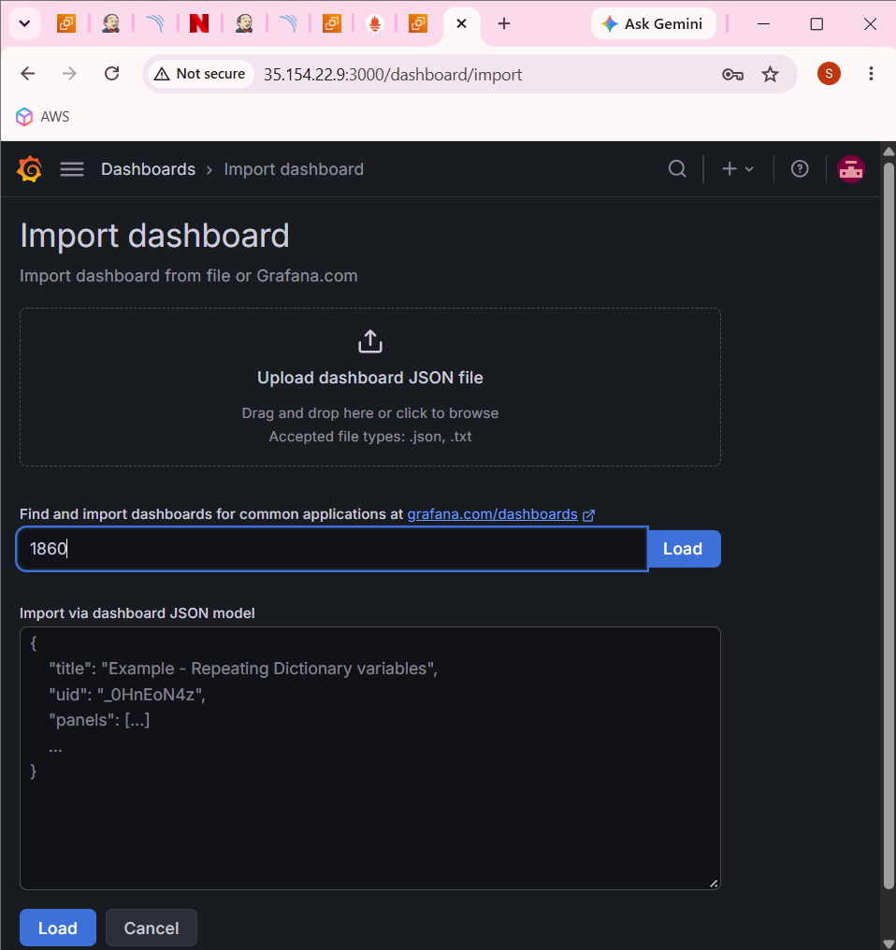

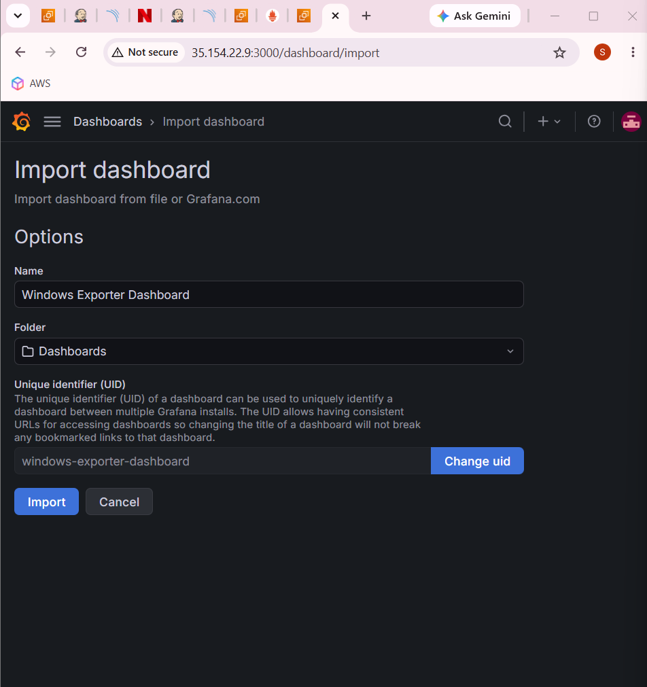

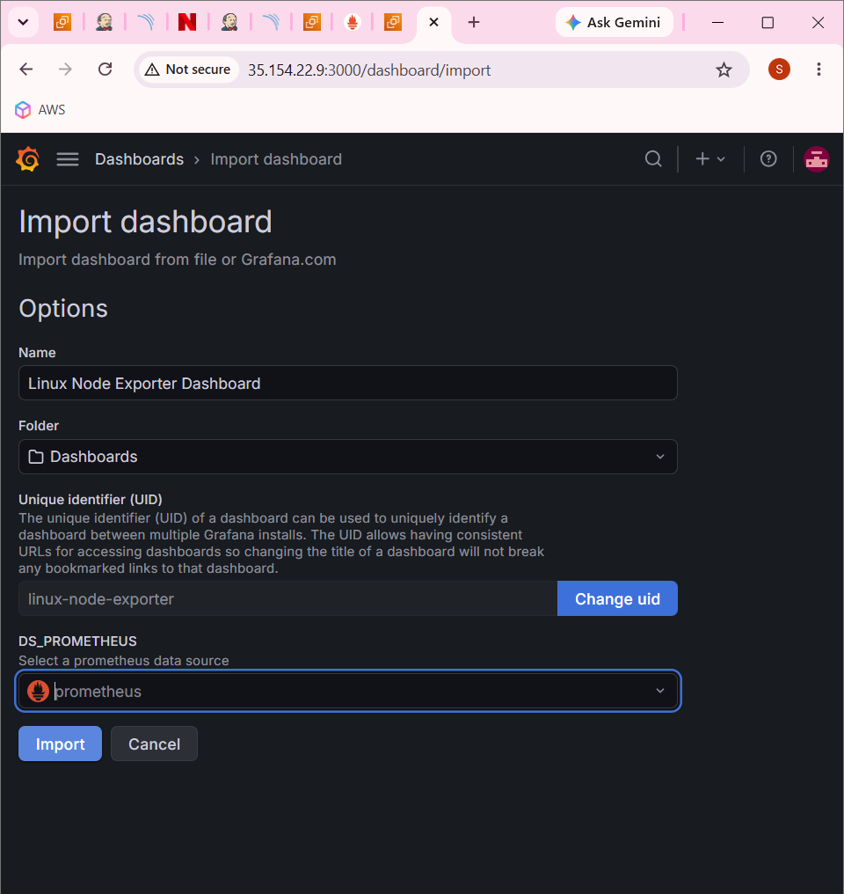

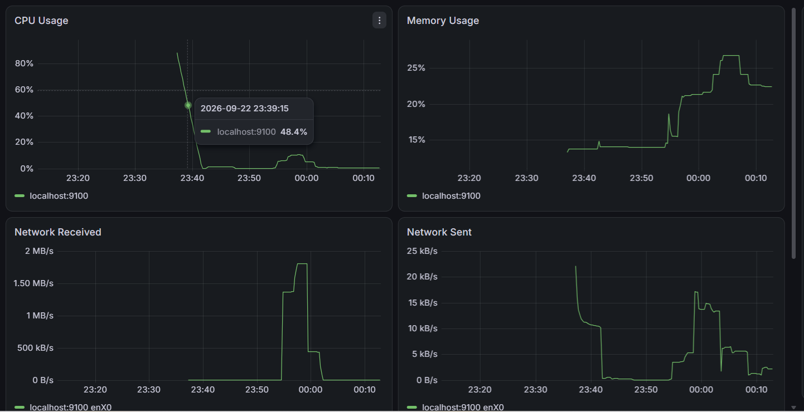

Grafana

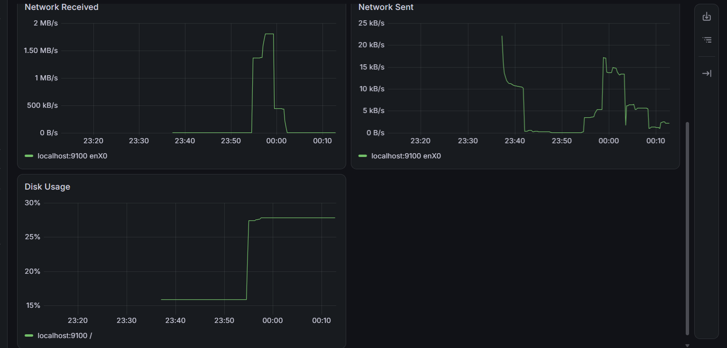

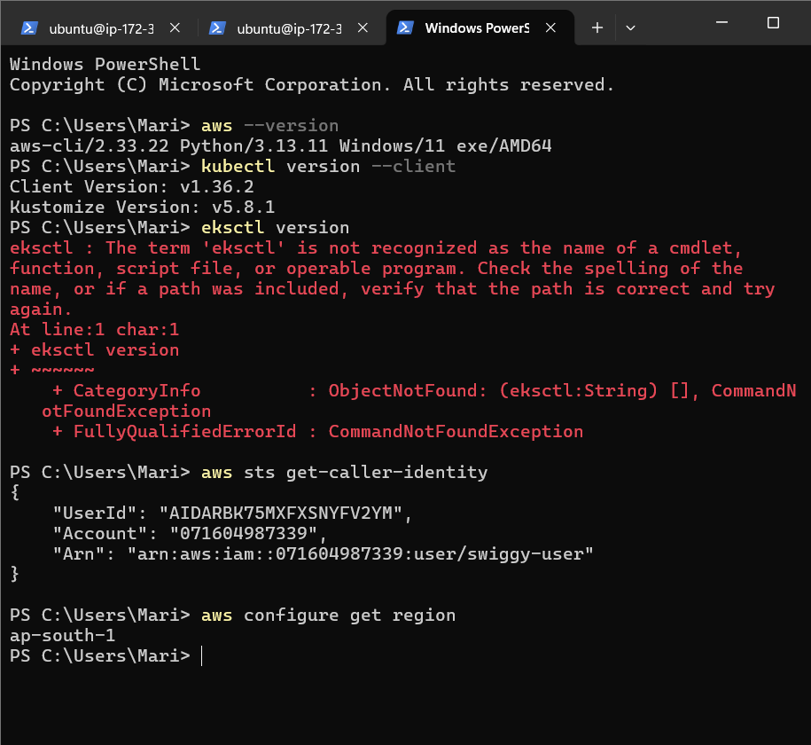

EKS





